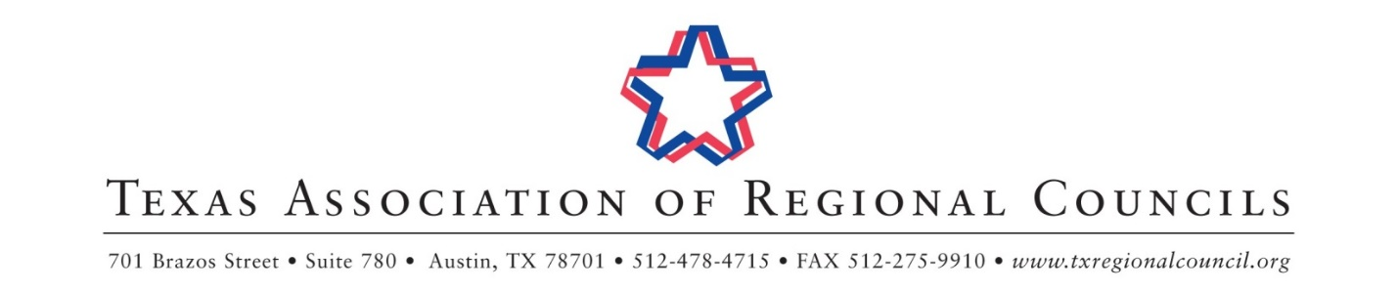

February 2020 Staff Training & Annual Board of Directors Meeting Schedule
Hilton Austin Airport

Tuesday, February 4, 2020
Office of Area Agencies on Aging Training | 1:00 pm – 5:00 pm | Del Valle
Wednesday, February 5, 2020
Community & Economic Development Training & Meeting | 9:00 am – 5:00 pm | Violet Crown
9-1-1 Coordinators’ Association Training & Meeting | 9:00 am – 5:00 pm | Del Valle
Finance and Personnel Association Training & Meeting | 9:00 am – 5:00 pm | Bergstrom A
Homeland Security Association of Texas Training & Meeting | 9:00 am – 5:00 pm | Bergstrom B
Criminal Justice Planners’ Association Training & Meeting | 9:00 am – 5:00 pm | Bergstrom C
Solid Waste Planners’ Association Training & Meeting | 9:00 am – 5:00 pm | Chennault
Texas Association of Area Agencies on Aging Training & Meeting | 9:30 am – 4:30 pm | Bergstrom D
Executive Directors’ Council Exchange | 3:00 pm – 5:00 pm | Winecup
Thursday, February 6, 2020
Emergency Communications Committee Meeting | 8:00 am – 9:00 am | Bergstrom C
Environmental Quality Committee Meeting | 8:00 am – 9:00 am | Bergstrom D
Transportation Committee Meeting | 9:00 am – 10:00 am | Bergstrom C
Public Safety Forum (Emergency Preparedness Committee + Criminal Justice and Law Enforcement Committee Meeting) | 9:00 am – 10:00 am | Bergstrom D
Community & Economic Development Committee Meeting | 10:00 am – 11:00 am | Bergstrom C
Health and Human Services Committee Meeting | 11:00 am – 12:00 pm | Bergstrom D
Executive Directors’ Council Meeting | 12:00 pm – 3:00 pm | Del Valle
TARC Legislative Committee Meeting & Collaboration Forum | 3:00 pm – 5:00 pm | Chennault
Friday, February 7, 2020
Budget & Bylaws Committee Meeting | 8:00 am – 9:00 am | Chennault
Coffee & Conversation | 9:00 am – 9:30 am | Bergstrom C/D
Board of Directors Meeting | 9:30 am – 12:00 pm | Bergstrom C/D

Updated 1/30/2020
*Meeting times and rooms subject to change
Please register to attend this meeting at: https://feb2020tarc.eventbrite.com

