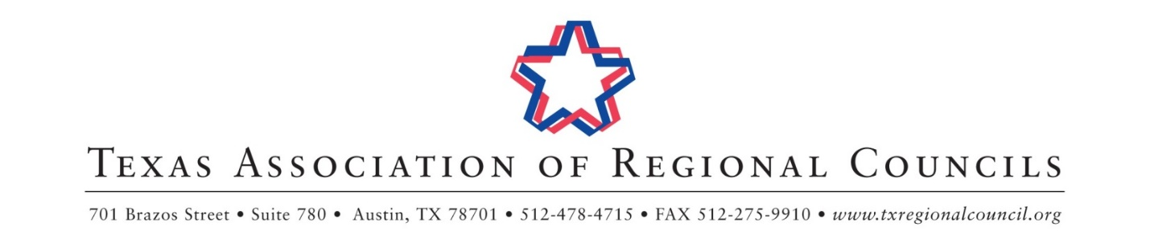

September 2018 Staff Training & Annual Board of Directors Meeting Schedule
Hilton Austin Airport

Tuesday, September 18, 2018
Texas Association of Area Agencies on Aging Training & Meeting | 9:30 am – 5:00 pm | Bergstrom A
Economic Development Administration Training | 1:00 pm – 5:00 pm | Bergstrom D
SWPA Field Trip to RECON Services | 2:30 pm – 5:00 pm | 6005 FM 973 S.
 |  | Del Valle, TX 78617
Wednesday, September 19, 2018
Finance and Personnel Association Training & Meeting | 8:30 am – 4:30 pm | Bergstrom A
Community & Economic Development Training & Meeting | 8:30 am – 5:00 pm | Del Valle
Solid Waste Planners’ Association Training & Meeting | 9:00 am – 3:30 pm | Chennault
9-1-1 Coordinators’ Association Training & Meeting | 9:00 am – 4:00 pm | Bergstrom D
Criminal Justice Planners’ Association Training & Meeting | 9:30 am – 5:00 pm | Bergstrom C
Homeland Security Association of Texas Training & Meeting | 1:00 pm – 5:30 pm | Bergstrom B
TARC Executive Directors’ Council Exchange | 3:00 pm – 5:00 pm | Wildflower
Thursday, September 20, 2018
Health and Human Services Committee Meeting | 8:00 am – 9:00 am | Bergstrom A
Emergency Communications Committee Meeting | 9:00 am – 10:00 am | Bergstrom D
Public Safety Forum (Emergency Preparedness Committee + Criminal Justice and Law Enforcement Committee Meeting) | 10:00 am – 11:00 am | Bergstrom A
Community & Economic Development Committee Meeting | 11:00 am – 12:00pm | Bergstrom D
Executive Directors’ Council Meeting | 12:00 pm – 3:00 pm | Chennault
TARC Legislative Committee Meeting & Collaboration Forum | 3:00 pm – 5:00 pm | Del Valle
Friday, September 21, 2018
Budget & Bylaws Committee Meeting | 8:00 am – 9:00 am | Del Valle
Coffee & Conversation | 9:00 am – 9:30 am | Bergstrom A/D
Board of Directors Meeting | 9:30 am – 12:00 pm | Bergstrom A/D

*Meeting times and rooms subject to change

Please register to attend this meeting at: https://sept18tarc.eventbrite.com.

