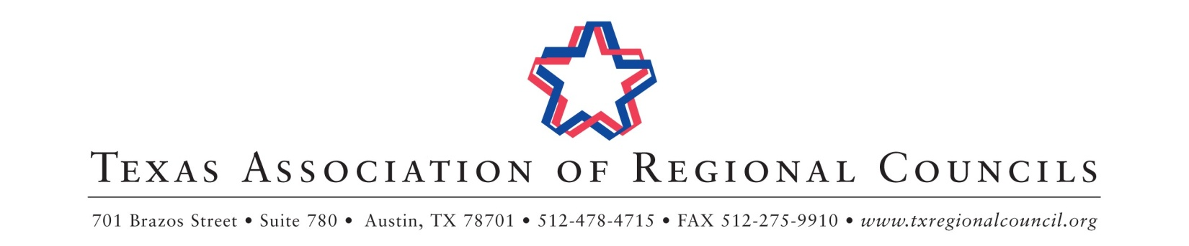

TARC Board of Directors &
Executive Directors’ Council June Meeting
June 21, 11:30 AM—June 22, 11:30 AM
Hilton Austin Airport

Schedule of Events

June 21, 2018

11:30am – 2:30pm TARC Executive Directors’ Council Meeting Del Valle
Lunch will be served

3:00pm – 5:00pm TARC Collaboration Forum & Legislative Committee Meeting Chennault

6:00pm – 7:30pm TARC Board & Executive Directors’ Council Dinner Del Valle

June 22, 2018

8:00am – 9:00am TARC Budget & Bylaws Committee Meeting Chennault

9:00am – 9:30 am Coffee & Conversation Bergstrom B/C

9:30am – 11:30am TARC Board of Directors Meeting Bergstrom B/C

