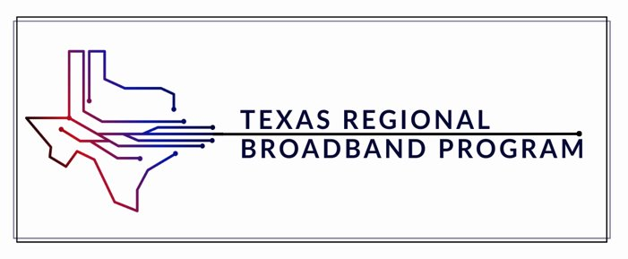

[COG Name]
Regional Plan for Broadband and Digital Opportunity

Template Packet
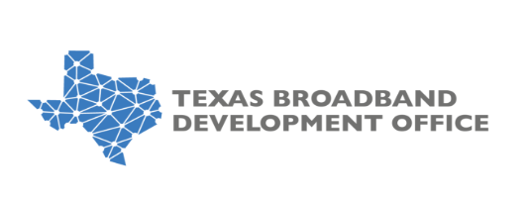
When ready to submit, please save as .docx or .pdf and email to the primary contact for TRBP, Alex Guerrero.
Table 1

Needs and Asset Assessment Summary
Area | Key Findings | Gaps | Implications for Planning Goals
Broadband Infrastructure
Digital Opportunity Gaps
Demographic and Economic Data
Existing Resources and Assets

Table 2

Digital Opportunity and Broadband Regional Planning - Objective X
Goal
Strategy
KPI
Target
Potential Regional Partners
*Note: Table 2 should be duplicated for each chosen goal and strategy to include all required information.

Table 3

KPI Tracker
Goal | Strategy | KPI | Baseline | Q1 | Q2 | Q3 | Q4
*Note: Table 3 should be duplicated for each chosen goal and strategy to include all required information.

Table 4

KPI Highlights and Milestones
Goal | Strategy | KPI | Narrative Update
*Note: Table 4 should be duplicated for each chosen goal and strategy to include all required information.

Table 5

Authorized By
COG
Title
Executive Director Name
Regional Digital Access Specialist Name
Date

When ready to submit, please save as .docx or .pdf and email to the primary contact for TRBP.

